EC 4209/AI 5209: Artificial Intelligence

Homework Assignment 2

Due Date: May11 , 2020.

**Part A:**

1. **Graph implementation**

Write a python code for the environment as shown in Figure-1, as undirected, unweighted graph G(V,E), where V represents a grid cell and an edge E between vertices represents the ability to traverse between those grid cells. Use the adjacency list to store the edges information.

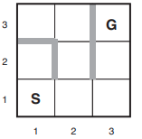Figure 1

1. **Implement BFS and DFS**

Implement BFS and DFS using the provided skeleton code. Visualize your solution using printpath function present in skeleton code.

Hint: A skeleton file hw2.py is provided.

**Part B: Tile Puzzle**

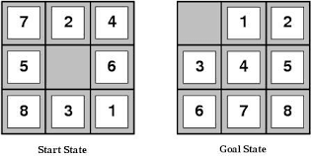

8-puzzle is one of the earliest heuristic search problems. The objective of the puzzle is to slide the tiles horizontally or vertically into the empty space until the configuration matches the goal configuration.

In order to solve the 8-puzzle, write a python code which includes following functionalities

1. Randomly initialize the puzzle
2. Give the state of the puzzle at any instant
3. Scramble the puzzle
4. Implement the solution using an iterative deepening search, consisting of a series of depth-first searches limited at first to 0 moves, then 1 move, then 2 moves, and so on. You may assume that the board is solvable. The order in which the solutions are produced is unimportant, as long as all optimal solutions are present in the output.
5. Write a python code for A* search using the Manhattan distance heuristic, assume that the board is solvable. During your search, you should take care not to add positions to the queue that have already been visited. It is recommended that you use the Priority Queue. The Manhattan distance heuristic for an entire puzzle is then the sum of the Manhattan distances between each tile and its solved location.

**Collaboration policy**

You must code your own solution to the problem without using or looking at other students’ code. You should not use any code you find online (except “reasonable”, small,< 5-line snippets that describe how to solve general programming tasks). You can use any other sources, books, websites to design your algorithm. You should cite any source you use.

**Submission**

Submit all the python files along with a report (pdf) explaining each implementation of your code and output of your algorithm. Answer in English is acceptable.